**Why DevOps in demand?**

DevOps is a set of practice that help development and operations work together which makes better collaboration and better communication between Developers and operation.

DevOps = Dev + Ops = Development + Operations

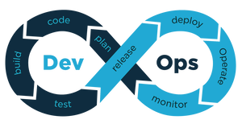

We need to go through different phases while developing software. As there are multiple components, like deadlines, analysis, planning, development, deployment, monitor, etc.

To make sure to develop software properly and on time without any error we need to follow

SOFTWARE DEVELOPMENT METHODOLOGY (SDLC):

Waterfall Model

Spiral Model

Agile Model

DevOps

We follow these Methodologies to develop software which has different phases one after another and each methodology have their own approach.

If we planned a perfect software development plan which will take almost 6 months and working on each, and every phase perfectly one after another according to plan without learning and applying new about customers, platform and technology. In the end of 6 months, It might will be a software development failure as we failed to deliver maximum value of customer because our software is according to demand of 6 months ago.

We need to continuously learn, develop, update or make adjustments in our plan to develop perfect software at the end. Learning and Progression is important for a product to be successful.

Only production phase is a phase where we will know about the real value of a product. Until production phase, we didn't know the real value and demand for product.

**So, what makes DevOps different from other methodology?**

* In other methodology, Feedback loops are only for development and feedback comes only from customers. But In DevOps, we look for the feedback loop for the entire delivery team including IT Operations. In DevOps, we not only look for how customer behaves but also how our infrastructure behaves and feedback comes from the team members which reduce implementation failure and recovery time.
* In DevOps, we automate as much as possible to get feedback loops as rapidly as possible. So that we can continue to improve and deliver small units of values rapidly.
* DevOps is flexible, as we don't need to care about the servers to deploy.
* DevOps focuses on constant testing and delivery and give equally importance to developing, testing and implementation phases. Whereas in others, developing software is more important and focuses on constant changes.
* DevOps is bug removal contributing to the progress and error free product of better quality. Its principle is to maximize efficiency when deploying software.
* In others, time is decided for each phases separately, but DevOps decides for deadline but code is delivered to production daily or every few hours and gives end-to-end solutions, and fast delivery.
* Increase the visibility of the work which is important to analyze and everyone in organization can know the current state of the work
* Deployment of a large product in large organization will take month because of large team members and have to go through many phases like integration test environments, long tests, manual testing and multiple approvals. In this workflow will be like this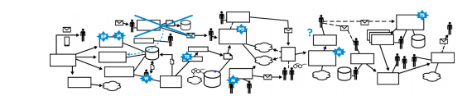

but in DevOps, this is possible in minutes or hours in worst cases. Workflow of DevOps will be like this

